**St. Francis Institute of Technology**

**Class: SE-ITA/ITB Semester: IV; A.Y. 2023-2024**

**Subject: Microprocessor Lab**

**Experiment – 9:** Check if given string is a palindrome or not

**1. Aim**:

Write an ALP to check if the given string is palindrome or not.

**2. Requirements**

DOSBox (an x86 emulator with DOS), Turbo Assembler, Turbo Debugger

**3. Pre-Experiment Exercise**

**Algorithm:**

a. Initialize the data segment with messages to take string input, display if the string is palindrome or not.

b. Write the macro for displaying message on the output screen.

c. Initialize the code segment. Use macro to display the message “Enter the string:$” d. Wait for input from the user and scan the string using INT 21H. While scanning, the assembler first stores the length of the buffer, next the length of the actual string followed by message. e. Use block transfer concepts to duplicate the string using SI and DI registers. f. Begin comparison between first and last of the string and check if they match or no. g. If they match, repeat for remaining part of the string. If all match, display message “String is palindrome$”.

h. If they don’t match, display message “String is not palindrome$”

**4. Laboratory Exercise:**

**Procedure:**

a. Open DOSbox and go to TASM.

b. Open a new document using the command - edit <filename>.asm

c. Write the Program and save the changes to the same file.

d. Assemble the program using the command - tasm <filename.asm>

e. If any errors are displayed, then change the code in <filename>

f. If no errors are displayed, execute the command - tlink <filename>.obj

g. Next execute the command - <filename>

**5. Post Experiment Exercise:**

a. **Results/Calculations/Observations:**

Along with ALP, attach at least one screenshot of display showing whether the entered string is palindrome or not.

b. **Questions:**

i. What is a procedure? Explain types of procedures in 8086.

ii. Differentiate between macro and procedure.

c. **Conclusion:**

Write the conclusion/comments based on the experiment performed and the output obtained. d. **References:**

Mention two book references and two web references.

**RIYA INDAP,44**

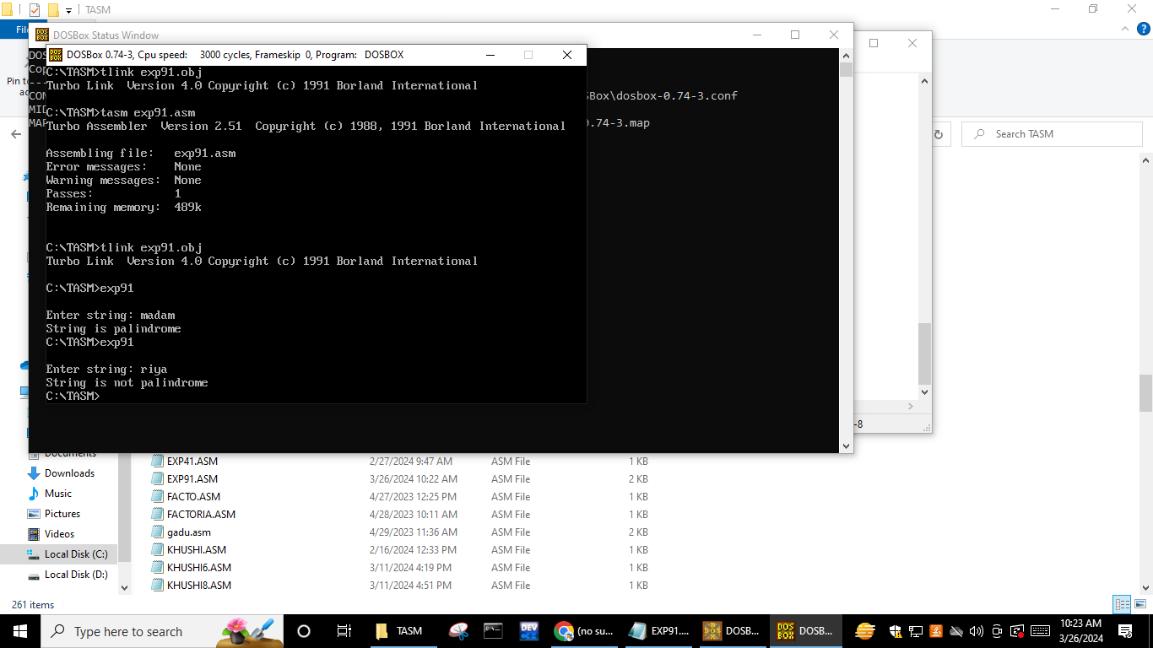

code:

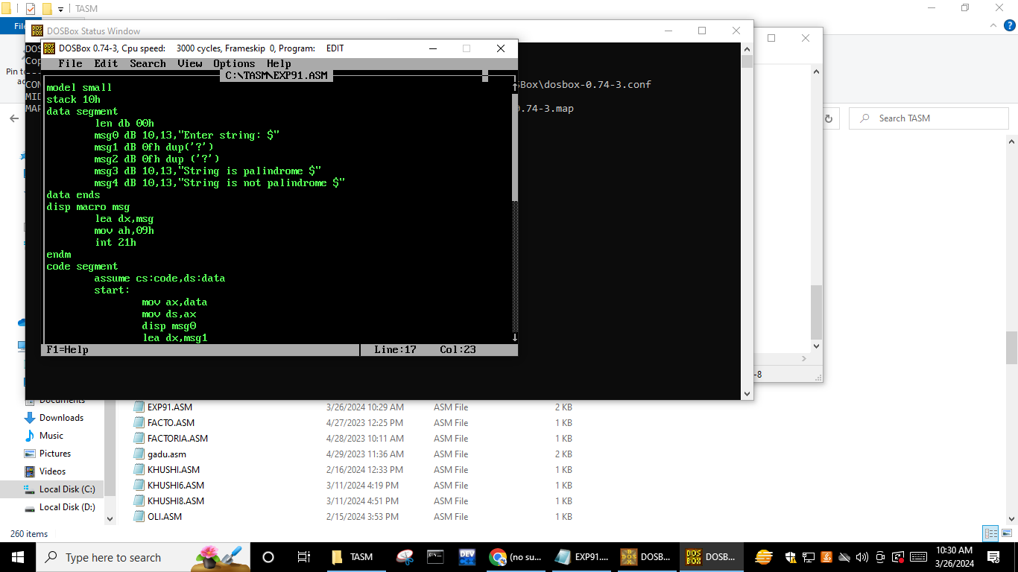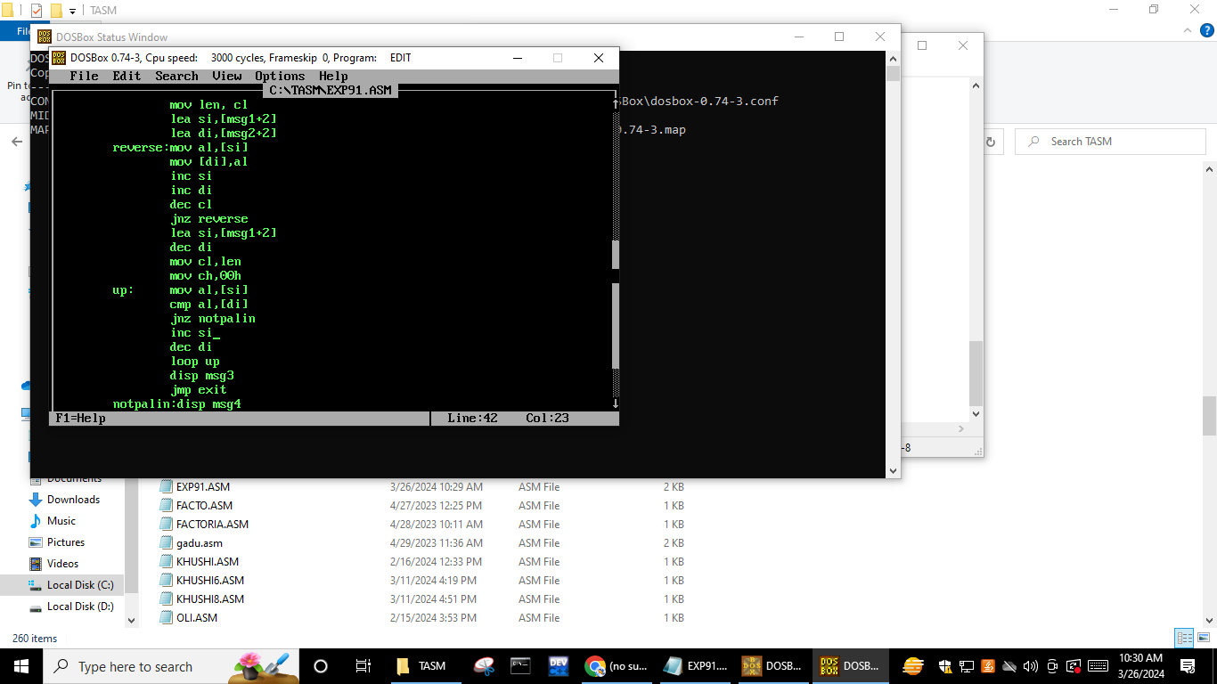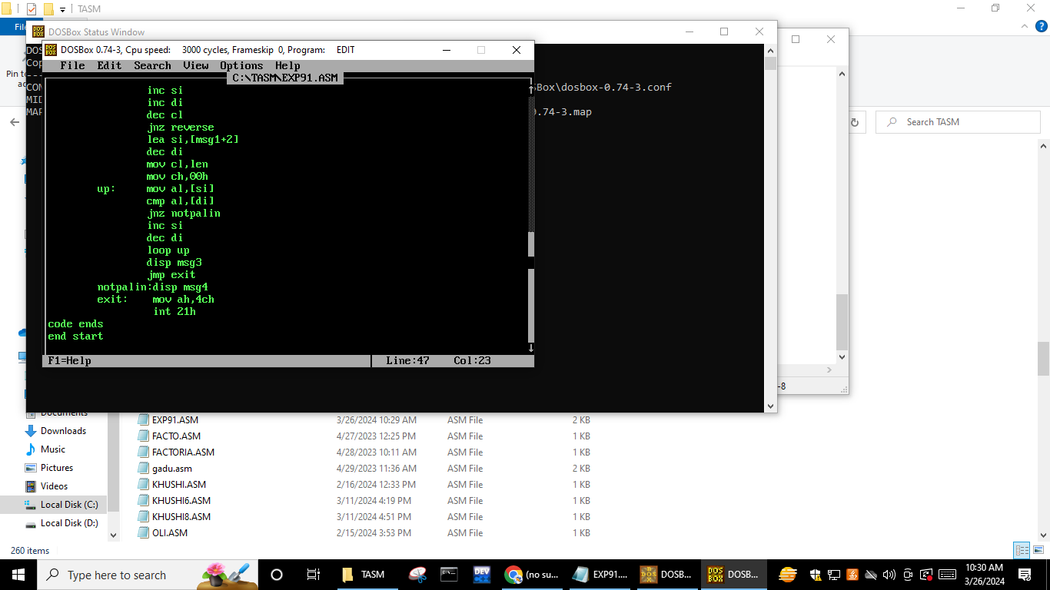

Output:

